REPUBULIC OF RWANDA WDA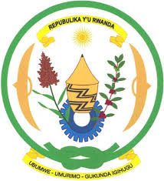 

**MINISTRY OF EDUCATION**

**WORKFORCE DEVELOPMENT AUTHORITY**

**COLLEGE ACEJ/KARAMA**

**TOPIC**: UNITY CLUB ONLINE REGISTRATION & INTERACTION SYSTEM

**CASE STUDY: Unity Club Rwanda**

**OPTION:** COMPUTER SCIENCE

**Submitted by: BAGIRISHYA Rwema** Dominique

**Supervised by: Eng. MURENZI** Deudone.

*For the award of the* ***A2 Level***

**

**Computer Science**

**COLLEGE ACEJ/KARAMA**

**September, 2017**

**Reg. No :** **020703017CSC001**

**Email :** [**acejcollege@gmail.com**](mailto:acejcollege@gmail.com)

**P.O. Box 108 MUHANGA**

PROJECT ID: CSC/Y6/17/001